**Department of Computer Science And Engineering Shree Guru Gobind Singh Tricentenary University Gurugram, Haryana 122505**

**May, 2023**



An Industrial Training Report On

##### UI/UX Development

Submitted in partial fulfilment of requirements for the award of the Degree of

##### Bachelor of Technology

In

##### Computer Science And Engineering

Submitted By**: Anjali khatri (1913020)**

Under the guidance of:

##### Mr.Aldrin

Asst. Professor

### CANDIDATE’S DECLARATION

I hereby declare that the work presented in this report entitled “**ZIA FOOD APP**”, in partial fulfilment of the requirement for the award of the degree **Bachelor of Technology** and submitted in the Department of Computer Science And Engineering of **SGT University,** Gurugram, is an authentic record of my own work carried out during the (8th sem) final year, 2019-2023 under the guidance of **Mr. Aldrin(Assistant Professor).**

The work reported in this has not been submitted by me for award of any other degree of this or any other institute.

(Anjali khatri) (191302025)

CERTIFICATE

This is to certify that the project report entitled “Zia’s Food App” being submitted by Anjali khatri in partial fulfilment for the award of the Degree of Bachelor of Technology in Computer Science and Engineering to SGT University is a record of bonafide work carried out by him/her under my guidance and supervision during Semester 8th(2023).

The results embodied in this project report have not been submitted to any other University or Institute for the award of any Degree or Diploma.

Name of HOD Name of Guide

Designation :Sahil Vashisht Designation: Mr. Aldrin

Department of Computer Science & Engg. Department of Computer Science &Engg.

COMPANY CERTIFICATE



## ACKNOWLEDGEMENT

I express my sincere gratitude to **Dr. Sahil Vashisht,** HOD Computer Science And Engineering, SGTU for providing me this opportunity, valuable guidance and suggestion throughout my training. I also wish to extend my thanks to **Mr. Aldrin** for their insightful comments and constructive suggestions to improve the quality of this project work and for providing me guidance and required resources for carrying out my project work.

Anjali khatri

191302025

**Table Of Contents**

* Preface
* Introduction
* Languages used
* Libraries used
* Project
* Output

# PREFACE

The project was made using the front end development. The website is designed and developed by me.

This is a portfolio website of ZIA PIZZA APP – A food company. The Application used in making this project are:

* FIGMA

# INTRODUCTION

**History of UI/UX Development**

Web development is the work involved in developing a Web site for the Internet (World Wide Web) or an intranet (a private network). Web development can range from developing a simple single static page of plain text to complex Web-based Internet applications (Web apps), electronic businesses, and social network services. A more comprehensive list of tasks to which Web development commonly refers, may include Web engineering, Web design, Web content development, client liaison, client-side/server-side scripting, Web server and network security configuration, and e-commerce development.

Among Web professionals, "Web development" usually refers to the main non- design aspects of building Web sites: writing markup and coding. Web development may use content management systems (CMS) to make content changes easier and available with basic technical skills.

For larger organizations and businesses, Web development teams can consist of hundreds of people (Web developers) and follow standard methods like Agile methodologies while developing Web sites. Smaller organizations may only require a single permanent or contracting developer, or secondary assignment to related job positions such as a graphic designer or information systems technician. Web development may be a collaborative effort between departments rather than the domain of a designated department. There are three kinds of Web developer specialization: front-end developer, back-end developer, and full-stack developer. Front-end developers are responsible for behavior and visuals that run in the user browser, while back-end developers deal with the servers.

# Basic

In practice, many Web developers will have basic interdisciplinary skills / roles, including:

Graphic design / Web design

Information architecture and copywriting/copyediting with Web usability, accessibility and search engine optimization in mind

Mobile responsiveness

## Testing

Testing is the process of evaluating a system or its component(s) with the intent to find whether it satisfies the specified requirements or not. Testing is executing a system in order to identify any gaps, errors, or missing requirements contrary to the actual requirements. The extent of testing varies greatly between organizations, developers, and individual sites or applications.

## LANGUAGES USED

**HTML** stands for Hypertext markup language. It is a basis of web development and is used to develop websites. It provides a basic structure of website.

**CSS** stands for cascading stylesheet. This provides a life to a website. CSS decides how the website will look. Cascading Style Sheets (CSS) is a simple mechanism for adding style (e.g., fonts, colors, spacing) to Web documents. These pages contain information on how to learn and use CSS and on available software. They also contain news from the CSS working group.

# PROJECT

The project was made using the UI/UX development. The website is designed and developed by me. The website is created from Figma.

This is an event management website of a company named ZIA PIZZA APP.

In this project first I developed the front-end part using HTML, CSS and FIGMA. The html is used to make the basic structure of the website. CSS is used to make the website interactive that is color, font, margin ,border, padding and there are many more css properties that I have used in this project. The libraries used that is bootstrap have many predefined classes that uses css properties and javascript functions.

**Project overview**

###### Zia's Pizza App Design

The product:

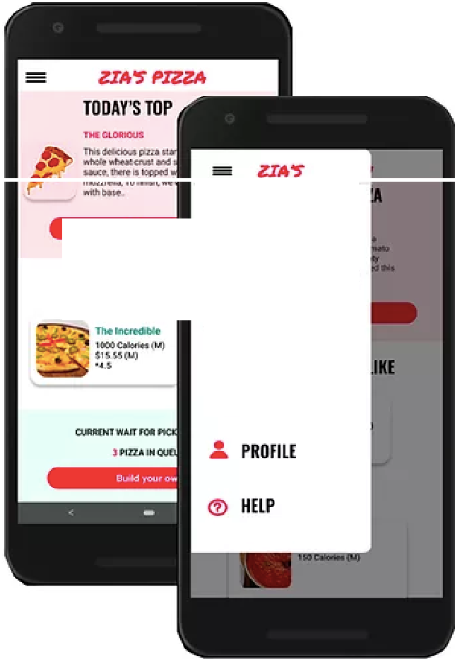

**HOME**

**PIZZAS YOU MIC** + **BUILD YOUR DWN**

**v/ BROWSE PIUAS**

o **smo**

Zia's Pizza is a regional pizza maker . Zia's Pizza strives to deliver healthy, specialty pizzas and side dishes. They offer a wide spectrum of competitive pricing. Zia's Pizza targets customers like commuters and workers who lack the time or ability *to* prepare a family dinner.

The problem:

Busy workers and commuters lack the time necessary to prepare a meal.

The goal:

Design an app for Zia's Pizza that allows users to easily order and pick up fresh, healthy dishes.

Responsibilities:

Conducting interviews, paper and digital wireframing, low and high-fidelity prototyping, conducting usability studies, accounting for accessibility, and iterating on designs.



**Paper wireframes**

Taking the time to draft iterations of each screen of the app on paper ensured that the elements that made **it** to digital wireframes would be well-suited to address user pain points. For the home screen, I prioritized a quick and easy ordering process to help users save time.

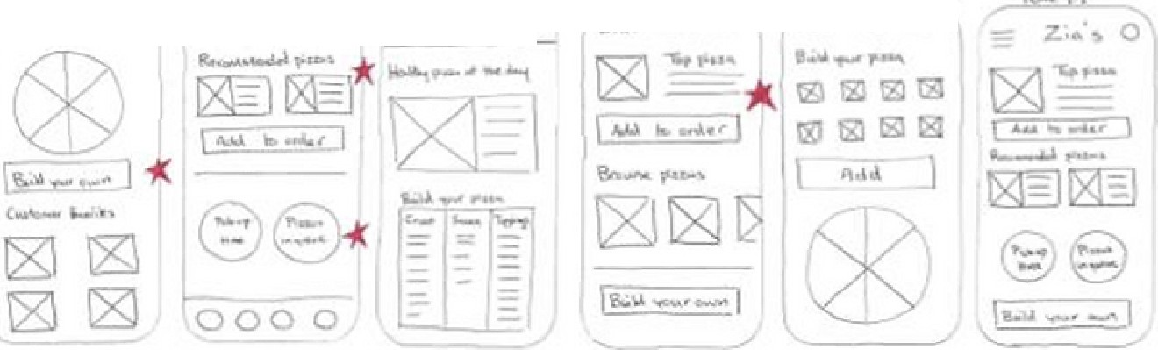

:::: z..- o ? *z,,,.':.* ""'ocoo

••



A **S**

**Digital wireframes**

As the initial design phase continued, I made sure to base screen designs on feedback and findings from the user research.

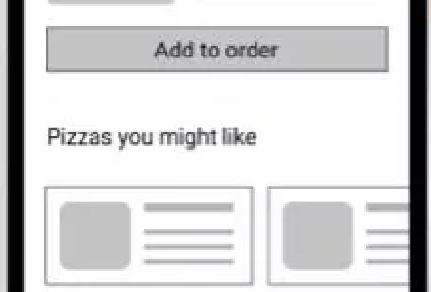

•

**Zla'sPlna**

**Tod.>ys Top Pino**

•

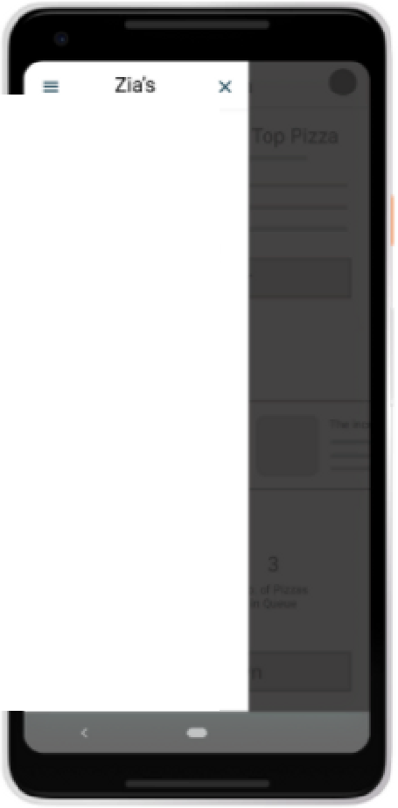

* **Home**
* Build Yoor Own
* **Browse Pizzas**
* Profile
* Help

**Low-fidelity prototype**

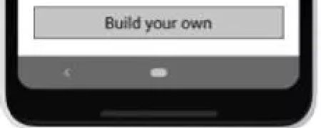

---

..-.

**Xmin**

·-

..**J**_

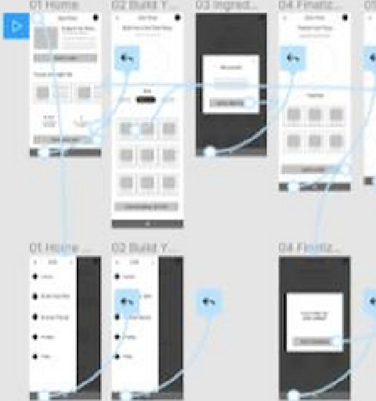Using the completed set of digital wireframes, I created a low-fidelity prototype. The primary user flow I connected was building and ordering a pizza, so the prototype could be used in a usability study.

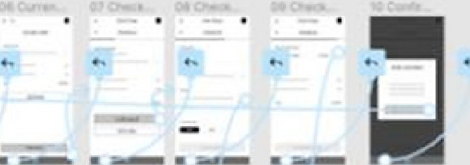

. ·-

Refining the design

* Mockups
* High-fidelity prototype

**Mockups**

Early designs allowed tor some customization.but alter the usability studies, I added additional options to choose pizza crust and sauce. I also revised the design so users see all the customization options when they first land on the screen.

Before usability studies After usability studies



•

**[il[il**

riHriHril



e

**IUILDYOUR an Pllli**

**Stll**

UUCI

**10PPlll1i5**

**Key mockups**

**e**

**IUILO G'W1PlllA**

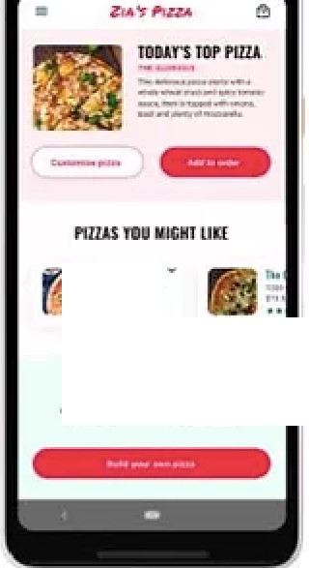

-....-.

-**ISM**-**.IN'**

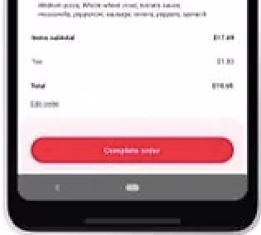

**CltitKIJlJT**

e

|  |
| --- |
|  |
| **,Al11CJIUIIP1WP** |
| - |



SIii



**High-fidelity prototype**

**II"**

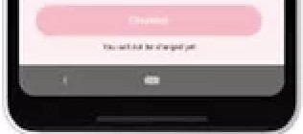""''

The final high-fidelity prototype presented cleaner user flows for building a pizza and checkout. It also met user needs for a pickup or delivery option as well as more customization.

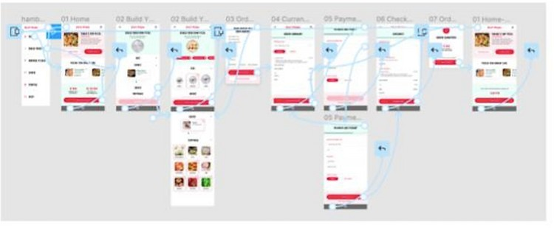

**OUTPUT**

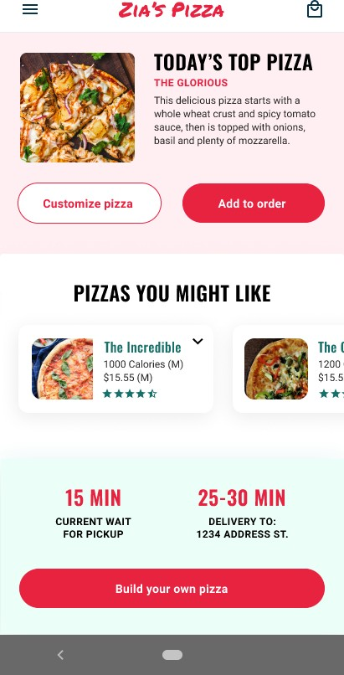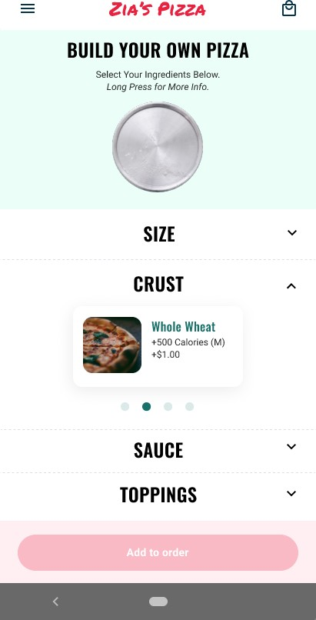

***ZIA PtZZA ZIA'S'PtZZAS***

###### BUILD YOUR OWN PIZZA

Select Your Ingredient Below.

#### ORDERSUMMARY

*Long* Press *for* More *Info.*

**ORDERING FROM**

Zia's- Watchung, NJ,USA ....

SIZE V

Plckup **Delivery**

1 Custom Pfz:za $77.89

Medium pizza, *whole whea* i c,us tomato sauce,

**CRUST** *mozzarella, pepperoni,* sausage, *oni011s, peppers, splnecl'J*

Add or edit items

**Whole** Wheat

+500 Calories (M)

+$1.00

•

**SAUCE** V

10PPINGS V

hems subtotal Si7.89

Ta:;_ S1.ao

Add tip

Total $19.69

Add to order

Add payment details

 

X

#### PAYMENT AND1 IPICKUP



### CHECKOUT



**PAYMENT INFORMATION ORDERING FROM**

Zia's -Watchung, NJ, USA ...

,,::,co:-xxxx-x:,;xx-12343

**x:o:.**

**PICKUP BY**

Lisa Fischer ASAP

**PAYMENT INFORMATION**

**PICKUP BY** Credit card: xxxx-xxxx-un-1234

Edit details

Lisa Fischer

**ORDER SUMMARY**

(908) 723-4511 Custom Pizza

Medium *pizza, Whole* wlleal *crusl, romaio* sauce,

mozzarella, *pepperon.i,* sausage, onions, *peppers, spine*ell

$17.89

**TIME OF PICKUP Items** sublotal **$17.89**

**ASAP Set a time** $1.80

Total $19.69

Edit order

Checkout

You will not b@ charged yet Complete order